
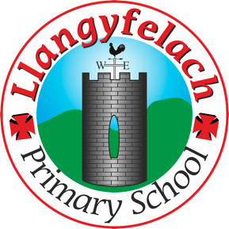
Llangyfelach Primary School
Pengors Road, Llangyfelach, Swansea SA5 7JE

Headteacher: Mr Lee Burnell
Deputy Headteacher: Mrs Claire Bate


Humanity Heroes Meeting:
20.5.26

SIP 1 | SIP 2 | SIP 3 | SIP 4
Enhance the quality of learner reflection and response to others. | Improving opportunities for learners to experience a more diverse and creative curriculum. | Provide real life learning experiences that are enriched using outdoor spaces, locally and wider. | Improve wellbeing provision for all within our community.

- Recap of Current Work
- Eco Schools Action Plan
- Meeting Targets and Actions
- Litter Pick
- Reducing Electricity Waste
- Playground Games Ideas
Minutes: |  | Actions
1. Recap of Current Work |  | discussed the work Humanity Heroes have already been doing in school, with a focus on:  - Recycling around the school  - Encouraging playground games and activities
2. Eco Schools Action Plan |  | looked at the Eco Schools Action Plan and discussed the renewal of the Eco Flag. Everyone shared ideas about how the school can continue to improve environmental awareness.
3. Meeting Target and Action Plan |  | - Year 3 and Year 4 classes need posters by the bins to help support correct recycling.  - Humanity Heroes will help remind pupils to recycle properly.
4. Litter Pick |  | - The group discussed organising a litter pick around the school grounds.  - Mr Flowers will be asked to help by providing equipment and resources.
5. Reducing Electricity |  | - The team discussed ways to save electricity in school.  Actions agreed:  - Humanity Heroes will take responsibility for turning off switches and lights when not in use.  - Posters will be created to remind everyone not to waste electricity.
6.Playground Games Ideas |  | - The group shared new ideas for playground games linked to recycling and sustainability.  - One idea was a “Recycling Bean Bag Toss” game

Attendees –

Hunter
Isla
Kingsley
Carter
Max
Cooper
Aria
Lennon

