
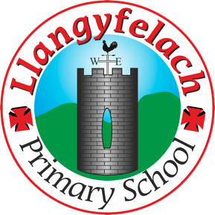
Llangyfelach Primary School
Pengors Road, Llangyfelach, Swansea SA5 7JE

Headteacher: Mr Lee Burnell
Deputy Headteacher: Mrs Claire Bate


Humanity Heroes Meeting:
11.5.26

SIP 1 | SIP 2 | SIP 3 | SIP 4
Enhance the quality of learner reflection and response to others. | Improving opportunities for learners to experience a more diverse and creative curriculum. | Provide real life learning experiences that are enriched using outdoor spaces, locally and wider. | Improve wellbeing provision for all within our community.

- Playground Games
- Monitor Recycling

Minutes: |  | Actions
1. | Playground Games | - Discussed new ideas for playground games.  - Aria and Carter will now be taking over responsibility for playground games.  - Ideas suggested included:  - Tin cans and bins game (hide-and-seek style activity)  - Basketball games  - Recycling posters  - Bean bag activities
2. | Monitor Recycling | - Positive feedback shared about recycling across the school.  - Almost all classes are recycling well in classrooms.  - Recycling on the yard has not been noticed as much yet, so outdoor bins will continue to be monitored.  - Responsibilities agreed:  Cooper and Max will monitor recycling during 1st play.  Isla will monitor recycling during 2nd play.
3 | Next meeting | - The group will discuss the Eco Charter and decide what we would like to create as a whole school.  - Ideas include:  - A rap song  - A poem  - Other creative projects to promote the Eco Charter across the school.

Attendees –

Hunter
Isla
Kingsley
Carter
Max
Cooper
Aria
Lennon
Zaya

