
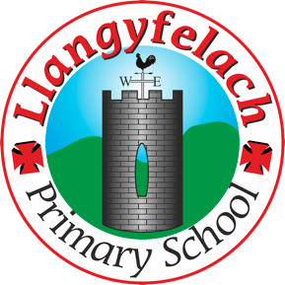
Llangyfelach Primary School
Pengors Road, Llangyfelach, Swansea SA5 7JE

Headteacher: Mr Lee Burnell
Deputy Headteacher: Mrs Claire Bate


Humanity Heroes Meeting:
24.3.26

SIP 1 | SIP 2 | SIP 3 | SIP 4
Enhance the quality of learner reflection and response to others. | Improving opportunities for learners to experience a more diverse and creative curriculum. | Provide real life learning experiences that are enriched using outdoor spaces, locally and wider. | Improve wellbeing provision for all within our community.

- Plan recycling assembly
- Discuss Eco Schools Action Plan

Minutes: |  | Actions
1. | - Plan recycling assembly meeting | - Discuss assembly  - Create PPT for assembly  - Decide who will say what
2. | Discuss Eco Schools Action Plan
3 | Other | 3. Bin Labels  - HH will design clear and easy-to-understand labels for recycling bins.  - Labels should help everyone know exactly what goes in each bin.  4. Education & Awareness  - After reviewing needs:  - HH will educate pupils and staff on:  - What can be recycled  - How to recycle correctly  - Why recycling is important  5. Discussion with Mr Flowers  - Mr Flowers discussed:  - Types of recycling (plastics, paper, etc.)  - The importance of having the correct bins in the right places.  - He has resources available for litter picking.  6. Litter Picking Initiative  - Organise litter picking in the yard during playtime.  - Use equipment provided by Mr Flowers.  - Encourage responsibility and pride in keeping the school clean.

Attendees –

Hunter Chukwuonye
Isla Beynon
Kingsley Richards
Carter Grey
Max Kift
Cooper Beynon
Aria Morgan
Bethan Brown
Lennon

