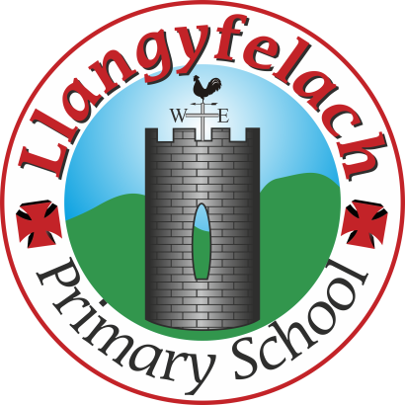
Llangyfelach Primary School
Strategic Equality Plan 2020 – 2025
Accessibility Plan

 |  | ACCESSIBILITY PLAN
Equality Strand | Objective / Action | Monitoring | People | Timeframes | Success
Access to curriculum | To increase access to the curriculum, physical and written environment through the delivery of this plan. | LPS Review Weeks  LPS SER | Class Teachers  SLT  ALNCo  Monitoring Committee  Pupil Voice Groups | On going | Pupils make progress from entry to the school and compare favourably with their peers locally and nationally.
Access to curriculum | Teachers to differentiate work in the light of reports below | Teachers Weekly Evaluations  Pupil progress meetings  LPS Review Weeks & SER |  | On going
Access to curriculum | Teachers work collaboratively with outside agencies and advise support staff accordingly | LPS Review Weeks  LPS SER |  | On going
Access to Physical environment | Needs of all stakeholders with  disabilities will be taken into account in planning and undertaking any refurbishment. | Plans and accommodation include adaptations. | LA  GB  SLT  Caretaker  H&S Committee  Surveyor | On going | Easy access to physical  Environment for the whole school community and any visitors to our building.
Access to Physical environment | Clear signage in all areas of the school | Termly checks. | LA  GB  SLT  Caretaker  H&S Committee  Surveyor | On going
Access to written environment | Visual support in place in all areas of the school | LPS Review Weeks  LPS SER | Class Teachers  SLT  ALNCo  Monitoring Committee  Pupil Voice Groups | On going | Clear access to written and pictorial info for all learners.  Access to written information does not inhibit learning and wellbeing.
Access to written environment | User-friendly language in place for all communication | Parental feedback |  | On going
Access to written environment | Communication translated into main community languages | Parental feedback |  | On going

