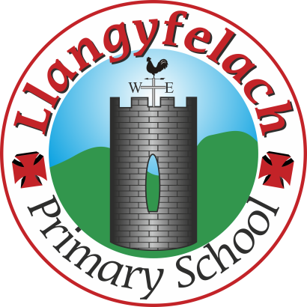
Llangyfelach Primary School
Strategic Equality Plan 2020 – 2025
Equality Objectives and Action Plan

Strand | Objective / Action | Monitoring | People | Timeframe | Success indicators
Protected  Characteristics | To promote messages and positive role models across all protected characteristics.  To increase participation and achievement within these groups.  Publish and promote Equality Policy through school website, newsletters, staff meetings, etc | Invitation for parents to respond to published document annually | SLT  GB | Annually | All staff familiar with principles of the policy and use them when planning lessons, creating classroom displays.  Parents are aware of policy and have communicated interest / amendments
Protected  Characteristics | Monitor and analyse pupil achievement by protected characteristics.  Act on trends and patterns in the data that require additional support in order to narrow potential gaps. | Achievement data analysed by protected characteristics | SLT  GB | Annually using  - Test data,  - FFT data  - Internal Tracking System  - Review Weeks | Analysis of teacher assessments/annual data indicates the gap is narrowing for equality groups.
Protected  Characteristics | Ensure the curriculum promotes role models that young people positively identify with, which reflect the school’s diversity | Increased pupil participation, confidence and achievement levels. | All staff | Ongoing | Increase in participation and confidence of all groups
Protected  Characteristics | Ensure that displays in classrooms and corridors reflect the diversity of the community we serve. | Increase in pupil participation, confidence and positive identity – monitor through Health & Wellbeing AoLE | SLT  H&WB Leader | On-going | More diversity reflected in school displays across all year groups
Protected  Characteristics | Ensure all pupils are given the opportunity to make a positive contribution to the life of the school.  e.g. through involvement in our Pupil Voice Groups | Consideration that all Pupil Groups reflect representation by race, gender, disability.  In order for all groups to experience Equality. | SLT | On-going | All Pupil Voice Groups, Teams, Clubs, etc reflect our diversity in order for all pupils to feel confidence and representation.
Racial Equality | Ensure racial incidents are reported, monitored and acted  upon effectively | The HT and GB will assess the impact of the school’s response to incidents i.e. have whole school/year group approaches led to a decrease in incidents, can repeat perpetrators be identified, are pupils/parents satisfied with outcomes? | HT  SLT  GB | Reporting in termly report to governors | All staff aware of and respond to racist incidents.  Consistent nil reporting is challenged by Governing Body  Pupils and Parents feel secure and trust the school to deal with incidents swiftly, with productive outcomes moving forward.
Gender Equality | To continue to encourage girls to take up sport outside the curriculum requirements, including football, cricket, basketball and rugby to ensure participation rates more reflective of school population. | Increased participation of girls in sports clubs and extra-curricular activities | HT  SLT  H& WB Leader  Sports Leader | Ongoing | More girls take up after school sport.
Disability Equality | Promote Governor vacancies with leaflets in accessible formats and specifically welcoming applications from disabled candidates | Monitoring of applications by disability to see if material was effective | SLT  GB | Ongoing | Increased number of applications from disabled candidates. Increased number of disabled GB members.
Racial | Celebrate cultural events throughout the year to increase pupil and community awareness of different ethnic groups and beliefs. Involve representatives from a range of these to participate in our celebrations. | Survey of participant and stakeholder | HT  SLT  H& WB Leader  GB | Ongoing | Increased awareness of different communities, beliefs and ethnicity.

