

Year 6 Cycle Training
Dear Parent/Carer

Swansea Council’s Road Safety Team have organised Cycle Training to be delivered at
llangyfelach Primary for Year 6 pupils on the following dates:

Mon 19th Feb - Fri 23rd Feb 2024

The cycle training is designed to give the next generation the skills and confidence to ride their bikes on today's roads following the Bikeability Trust Guidelines. Instructors will introduce cycling as an everyday, fun, healthy activity, and an alternative mode of transport. All training is FREE and is delivered by qualified instructors, who are DBS checked and hold a First Aid qualification.

What will my child need?
- To be able to ride their bike along unaided and have a minimal level of bike-handling skills.
- A signed consent form. Complete the form overleaf and return by the date specified.
- A helmet which fits securely - Full face helmets are not permitted.
- A bike, which is road worthy. Follow the simple guide below to check your child’s bike before training starts. Electric bikes known as ‘electrically assisted pedal cycles’ are not permitted unless the participant is over 14 years old.
- Appropriate clothing and footwear. It is important, especially during the cooler months that children wear warm, dry clothing, as they will be outside for 2 hours.

Level 1 cycle training will take place in the school yard and participants will need to demonstrate sufficient progress at Level 1 to participate in Level 2 training which will be delivered on the road.

Handlebars and saddle: Please check these are adjusted to the correct height
and are not loose.

Brakes: Please check that both front and back brakes work and can be used by your child.

Tyres: Please check these are fully inflated.

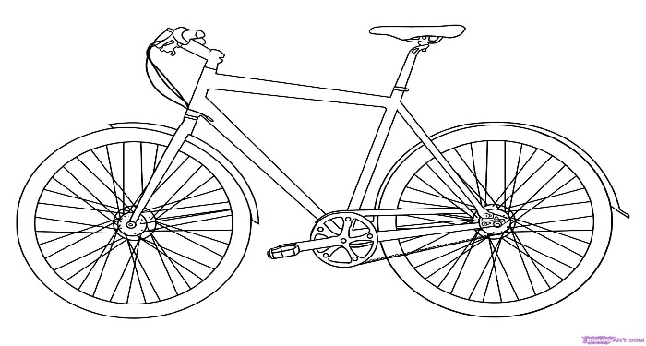

Please note that your child will not be able to participate
if their bike is considered unsafe.

Cycle Training Consent Form.

Please complete and return to school no later than: Friday 2nd February 2024
Child’s name:

School Name:
& Class
Any relevant medical
Information:

I give permission for instructors to carry out basic maintenance on my child’s bike if necessary. | Yes/No (please circle)
Should a classmate not have a suitable bike for the training, I am happy for my child to share their bike if the instructor also agrees. | Yes/No (please circle)
My child can ride a bike unaided and has basic level of cycle handing skills | Yes/No (please circle)
Name of parent/carer

Emergency contact number:

My child is responsible for their own behaviour, and I understand that cycle training may be refused if my child’s behaviour puts them at risk to themselves or others.

Signed:.................................................... Date ..................

For further information please contact: road.safety@swansea.gov.uk

General Data Protection Regulations
Swansea Council is the data controller for the personal information you provide as a parent/carer of a child participating in cycle training. Your information and your child’s information will only be used for the delivery of cycle training and will not be used for any other purpose. Data protection law describes the legal basis for us processing your data as necessary for the performance of a public task. For further information about how Swansea Council uses your personal data, including your rights as a data subject, please see our corporate privacy notice on our website.

