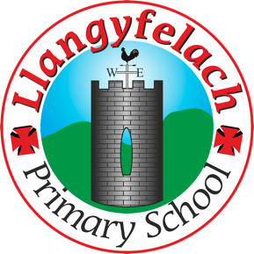
Llangyfelach Primary School
Pengors Road, Llangyfelach, Swansea SA5 7JE

Headteacher: Mr Lee Burnell
Deputy Headteacher: Mrs Claire Bate


Creative Crew Meeting
12/03/20

SIP 1 | SIP 2 | SIP 3 | SIP 4
Enhance application of key and wider skills across all Areas of Learning. | Further improve ALN provision throughout the school to meet the needs of all pupils. | Embed provision for self-determined learning. | Enhancing leadership skills at all levels through the research and development of the new Areas of Learning.

- Previous Minutes & Actions
- Welsh artists
- Into Film Clips
- AOB

Present – Miss Evans, Vinny, Julia, Sophie, Logan, Mollie, Maya, Oliver, Tewdwr

Minutes: |  | Actions
1 | All points actioned.
2 | Logan, Vinny, Olivia and Oliver handed in their research. The others to hand in tomorrow. | Collect outstanding research, collate list for EA AoLE Folder
3 | Miss Evans showed KS2 and FP clips to crew. Crew decided which clips would be suitable for which year group.  Welsh Merlin and the Dragons – Y2  Heart Strings – N, R  The Welsh Flag – Y1, Y2, Y3, Y4  How the Draig came to fly for Wales – Y1, Y2  Gelert – Y5, Y6  Wales: The greatest Welsh side ever – Y3, Y4  Manic Street Preachers Together Stronger – Y4 | Miss E to forward clips to class teachers
4 | N/A

