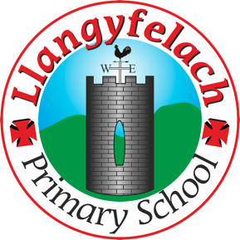
Llangyfelach Primary School
Pengors Road, Llangyfelach, Swansea SA5 7JE

Headteacher: Mr Lee Burnell
Deputy Headteacher: Mrs Claire Bate


Creative Crew Meeting
27/02/20

SIP 1 | SIP 2 | SIP 3 | SIP 4
Enhance application of key and wider skills across all Areas of Learning. | Further improve ALN provision throughout the school to meet the needs of all pupils. | Embed provision for self-determined learning. | Enhancing leadership skills at all levels through the research and development of the new Areas of Learning.

- Previous Minutes & Actions
- Easter Competition
- Expressive Arts Resource Audit
- CC Research
- AOB

Present – Miss Evans, Olivia, Vinny, Julia, Logan, Mollie, Maya, Oliver,

Minutes: |  | Actions
1 | All points actioned.
2 | Decided that we’re not going to do an Easter comp this year. Going to do a summer comp instead.  Vinny suggested that KS2 could create a summer landscape and FP could design an ice-cream or a beach ball. | Follow up after Easter hols.
3 | Miss Evans told Crew that art order has arrived. | Crew delivered art resources to various classes
4 | Miss Evans asked Crew to research Welsh artists and what element of art they specialise in. We can then compile a list and give to class teachers, so they can work in the style of and appreciate Welsh artists when completing art activities. | Crew to complete research by 12/3/20
5

