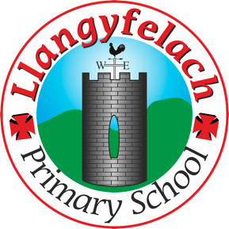
Llangyfelach Primary School
Pengors Road, Llangyfelach, Swansea SA5 7JE

Headteacher: Mr Lee Burnell
Deputy Headteacher: Mrs Claire Bate


Creative Crew Meeting
16/01/20

SIP 1 | SIP 2 | SIP 3 | SIP 4
Enhance application of key and wider skills across all Areas of Learning. | Further improve ALN provision throughout the school to meet the needs of all pupils. | Embed provision for self-determined learning. | Enhancing leadership skills at all levels through the research and development of the new Areas of Learning.

- Previous Minutes & Actions
- 3D Art in different topics
- Expressive Arts Resource Audit
- Easter Competition
- Assembly Monday D2S
- AOB

Present – Miss Evans, Olivia, Vinny, Julia, Sophie, Logan, Mollie, Maya, Oliver, Liberty, Tewdor

Minutes: |  | Actions
1 | All points actioned.
2 | Carried on discussion from before Christmas.  Showed theme coverage to crew.  Crew suggested more ideas .  Will finalise in future meetings. | Follow up
3 | Miss Evans asked Crew to speak to their class teacher about what resources they need for art. | Crew to report back to Miss Evans.
4 | Discussed possible Easter art comp for this year. Miss Evans wants it to be different from Easter eggs.  Crew to think about ideas and discuss in a future meeting. | Follow up
5 | Miss Evans informed the Crew that a member of our school won the D2S art competition and winner well be announced in Monday’s assembly.  Well done to the crew for hosting the competition. | Completed
6

