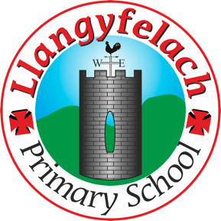
Llangyfelach Primary School
Pengors Road, Llangyfelach, Swansea SA5 7JE

Headteacher: Mr Lee Burnell
Deputy Headteacher: Mrs Claire Bate


Creative Crew Meeting
14/11/19

SIP 1 | SIP 2 | SIP 3 | SIP 4
Enhance application of wider skills across all Areas of Learning in readiness for the Curriculum 2022. | Further improve ALN provision throughout the school in readiness to meet the new ALN Legislation. | Embed provision for self-determined learning supporting the Curriculum 2022  (FP Challenge Boards)  (KS2 Topic Webs) | Enhancing leadership skills at all levels through the research and development of the new Areas of Learning within Curriculum 2022.

- Previous actions and minutes
- Review Week monitoring
- 3D art
- AOB

Present – Miss Evans, Vinny, Julia, Sophie, Logan, Mollie, Maya, Oliver, Liberty, Tewdwr.

Minutes: |  | Actions
1 | No more ideas for developing literacy, numeracy and ICT within Expressive Arts. Will continue to discuss this at future meetings. | Ongoing
2. | On Friday 22nd November, Mrs Scrine will be coming in to monitor Expressive Arts with us.  We will be doing a learning walk looking for art around the school.  We will monitor the Expressive Arts on the website.  We will talk to learners.  Questions member of the Creative Crew think we should ask the learners:  - What art have you done so far this year?  - What music have you done so far this year?  - How often do you use musical instruments?  - Have you created any 3D art this year so far? | Ongoing
3. | Discuss to a future meeting. | Ongoing
4. | N/A

