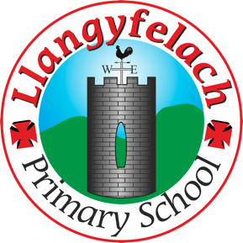
Llangyfelach Primary School
Pengors Road, Llangyfelach, Swansea SA5 7JE

Headteacher: Mr Lee Burnell
Deputy Headteacher: Mrs Claire Bate


Creative Crew Meeting
07/11/19

SIP 1 | SIP 2 | SIP 3 | SIP 4
Enhance application of wider skills across all Areas of Learning in readiness for the Curriculum 2022. | Further improve ALN provision throughout the school in readiness to meet the new ALN Legislation. | Embed provision for self-determined learning supporting the Curriculum 2022  (FP Challenge Boards)  (KS2 Topic Webs) | Enhancing leadership skills at all levels through the research and development of the new Areas of Learning within Curriculum 2022.

- How can we develop literacy, numeracy and ICT within art?
- How can we develop literacy, numeracy and ICT within music?
- How can we develop literacy, numeracy and ICT within drama?
- How can we promote more 3D art in LPS?

Present – Miss Evans, Vinny, Olivia, Julia, Sophie, Logan, Mollie, Maya, Oliver, Liberty, Tuwdwr.

Minutes: |  | Actions
1 | Writing stories and poems linked to art work.  Writing biographies of famous artists.  Discussing feeling and emotions linked to art (writing and oracy.)  Maths – Tesselations  ICT – Art on J2E  Uploading images of artwork. | Ongoing
2. | Use Garageband.  Use ipad keyboards.  Record performances to appraise.  Write appraisals – literacy (writing / oracy)  Write song lyrics. | Ongoing
3. | Write playscripts.  Film drama using ipads.  Create and edit iMovies. | Ongoing
4. | Made a start on this  Stargazers – make 3D planets, papier mache  Victorians – Victorian Houses  Wonderful World – 3D 7 Wonders  Castles and Dragons – Dragons using air-drying clay  Towers, Tunnels and Turrets – 3D castle | Will continue in next meeting

