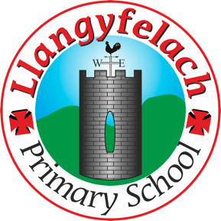
Llangyfelach Primary School
Pengors Road, Llangyfelach, Swansea SA5 7JE

Headteacher: Mr Lee Burnell
Deputy Headteacher: Mrs Claire Bate


Creative Crew Meeting
04/10/19

SIP 1 | SIP 2 | SIP 3 | SIP 4
Enhance application of wider skills across all Areas of Learning in readiness for the Curriculum 2022. | Further improve ALN provision throughout the school in readiness to meet the new ALN Legislation. | Embed provision for self-determined learning supporting the Curriculum 2022  (FP Challenge Boards)  (KS2 Topic Webs) | Enhancing leadership skills at all levels through the research and development of the new Areas of Learning within Curriculum 2022.

- D2S Competition

Present – Miss Evans, Vinny, Olivia, Julia, Sophie, Logan, Mollie, Maya, Oliver

Minutes: |  | Actions
1 | The CC judged the competition entries. They used the criteria set by the competition to judge. They didn’t judge their own class, to make it fair.  The winners were  Khloe Chung – Nursery  Carter Davies – Year 1  Zac Coleman – Year 2  Alyssa Giffard – Year 3  Kenzo Williams – Year 4  Evie Brown – Year 5 | Miss Evans to email winning entries to D2S.

