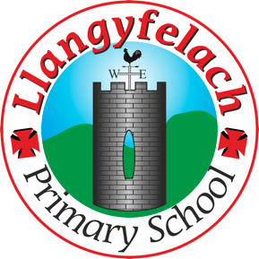
Llangyfelach Primary School
Pengors Road, Llangyfelach, Swansea SA5 7JE

Headteacher: Mr Lee Burnell
Deputy Headteacher: Mrs Claire Bate


Creative Crew Meeting
16/09/19

SIP 1 | SIP 2 | SIP 3 | SIP 4
Enhance application of wider skills across all Areas of Learning in readiness for the Curriculum 2022. | Further improve ALN provision throughout the school in readiness to meet the new ALN Legislation. | Embed provision for self-determined learning supporting the Curriculum 2022  (FP Challenge Boards)  (KS2 Topic Webs) | Enhancing leadership skills at all levels through the research and development of the new Areas of Learning within Curriculum 2022.

- D2S Competition

Present – Miss Evans, Julia, Sophie, Logan, Mollie, Maya, Oliver

Minutes: |  | Actions
1 | Miss Evans explained to the children about the Designed to Smile Art Competition.  Miss Evans explained the competition criteria so that they could answer any pupil in the school if they asked them a question.  Miss Evans explained that as only 1 entry per year group can be sent off, CC will be judging each class, choosing the one winning entry. CC will be doing this anonymously and will not be able to judge their own class. | Children to judge competition entries

