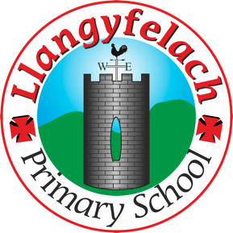
Llangyfelach Primary School
Pengors Road, Llangyfelach, Swansea SA5 7JE

Headteacher: Mr Lee Burnell
Deputy Headteacher: Mrs Claire Bate


Creative Crew Meeting
05/09/19

SIP 1 | SIP 2 | SIP 3 | SIP 4
Enhance application of wider skills across all Areas of Learning in readiness for the Curriculum 2022. | Further improve ALN provision throughout the school in readiness to meet the new ALN Legislation. | Embed provision for self-determined learning supporting the Curriculum 2022  (FP Challenge Boards)  (KS2 Topic Webs) | Enhancing leadership skills at all levels through the research and development of the new Areas of Learning within Curriculum 2022.

- Previous Minutes & Actions
- PVG Recruitment
- PVG Recruitment PPT
- Lunchtime Music
- New ideas for the year
- AOB

Present – Miss Evans, Olivia, Vinny, Julia, Sophie, Logan, Mollie, Maya, Oliver

Minutes: |  | Actions
1 | First meeting of the new academic year. | Ongoing
2 | Miss Evans explained that we will be recruiting two new members of the Creative Crew from Year 2. | Completed
3 | Powerpoint to be made and shown in assembly on Tuesday 10th September. Include all successes from last year including competitions, toilet redesign and monitoring.  Miss Evans asked what qualities our new members should have. Suggestions were; confident, creative, good thinkers and good listeners, inspire others, has a voice. | Miss E to create PPT. Crew to edit it on Monday 9th September
4 | Miss Evans explained that we are going to be playing music from famous composers during lunchtimes to calm the children whilst eating. CC to research composers and we will compile a list at a later date. | Follow up
5 | The Crew remembered that we need to focus on drama this year. They suggested theatre visits or drama people coming in to work with the children. | Miss E to follow up
6 | The Crew reminded Miss Evans that we need a new photo for the wall. Miss Evans said we’d wait until the new members had joined us. | Complete when CC is complete

